Darwin Roller Girls
2019 Membership Payment Schemes

Annual DRG Membership
Annual membership fees are for all skaters, referees and NSOs. This is a one-off payment to be made when you submit your membership forms.
- $20.00 new members
- $10.00 membership renewal

Training Schedule
In 2019 the DRG season will consist of a number of ‘blocks’, members can pay up-front per block, or via direct debit either weekly, fortnightly, or monthly.

BLOCK 1: Recreation and Development - 20th January to 13th April – ALL LEVELS

STAR LEVEL | UPFRONT COST | TOTAL COST – DIRECT DEBIT | DIRECT DEBIT (WEEKLY) | DIRECT DEBIT (FORTNIGHTLY) | DIRECT DEBIT (MONTHLY)
Intake | $ 60  Five Week Program  Does not include cost of hire skates + safety equipment | NA | NA | NA | NA
Fresh Meat | $ 60  Five Week Program  Does not include cost of hire skates + safety equipment | NA | NA | NA | NA
White Star | $240 | $265 | $24.09 x 11 payments | $44.17 x 6 Payments | $66.25 x 4 payments
Yellow Star | $240 | $265 | $24.09 x 11 payments | $44.17 x 6 Payments | $66.25 x 4 payments
Orange Star | $240 | $265 | $24.09 x 11 payments | $44.17 x 6 Payments | $66.25 x 4 payments
Skater – Refs* | $120 | $150 | $13.64 x 11 payments | $25 x 6 payments | $37.50 x 4 payments
Coaches* | $120 | $150 | $13.64 x 11 payments | $25 x 6 payments | $37.50 x 4 payments
Ref / NSO Only | FREE | NA | NA | NA | NA

*Discounted rate for “Skater –Ref” offered to those members who wish to act as a referee, but also want to participate in on-skates training activities. These people must be willing to commit to acting as an official for 75% of all scrimmages + events, as rostered by the officials subcommittee core 5. If a member has chosen “Skater – Ref”, but then does not full fill this requirement, they will be charged additional fees at the end of the block and an invoice will be emailed to them.
*Discounted rate for “Coaches” offered to those members who wish to act as a coach during this block, including taking on responsibility for one star level for the entirety of the block, creating training plans in partnership with the training subcommittee and other coaches, delivering training sessions, set up and pack down of training sessions (getting out bibs, cones, etc.), marking competencies, ensuring safety in all drills and scrimmages, etc. This discount is not offered to “assisting coaches”. If a member has chosen “Coach” on their payment form, but then does not fulfil the requirements, they will be charged additional fees at the end of the block and an invoice will be emailed to them

BLOCK 2: Travel Team - May to July (dates TBC)
TBC at a later date

BLOCK 3: Home Teams + Development and Recreation – August to November (dates TBC)
TBC at a later date

Extra fees:
- Skate Hire per session: $5.00 (cash accepted)
- Gear Hire per session: $5.00 (cash accepted)
- Personal training/practice at sides of stadium during other training: $5 per session (cash accepted) – no coaches provided
- Teflon: $10 per strip - enough for 2 knees and 2 elbows (cash accepted)
***It is a requirement of ALL members to have Teflon on their safety gear. This protects the floor surface, and ensures that we will continue to be welcomed back at Mararra Indoor Stadium
- Insurance: as per Insurance Form. Fees are to be paid to Darwin Roller Girls via bank transfer, as per details above.
***NOTE: These fees are NOT set by DRG, and we have no control over them. You MUST be insured to participate in any DRG related activities
- GAME LEVY: This year we will be introducing a game levy. This is a $10 fee, per skater, per Game (Bout) they participate in. The game levy is to be paid for all exhibition games, home bouts, and other events that are open to the public. These fees will be collected before each event to fund bout expenses such as St. John’s Ambulance, Photographers, Half Time Entertainment, Officials appreciation, etc.

Conditions
- Skate/gear hire is only available to learning skaters and beginners unless otherwise approved by the Management Committee.
- Individuals who wish to practice at the sides of the stadium during other levels’ training sessions must ensure to not distract or hinder the training sessions in progress. The charge of $5 per session will apply no matter how long the individual wishes to practice for and can be paid in cash.
- Direct debit and up-front payments help making payments easier for each player and help the League keep track of funds. We will no longer be accepting weekly payments by cash for any training session. If you have any questions or concerns regarding payment, please email the management committee: darwinrollergirls@gmail.com
- Payments are block training fees and not per session (unless otherwise stated). This means that regardless of how many training sessions you attend, you will still pay the level amount. Refunds will not be issued for sessions not attended. Special circumstances will be considered on a case by case basis by the Management Committee

Methods of Payment
All skaters must pay via Direct Debit (DD) or lump sum (see table above). DD form will be distributed with membership forms. Alternatively, a DD form will be provided to you by email, upon request to the management committee.
Cash will only be accepted for extra fees, as outlined above.

Suspending Fee Payments
If your fees are being paid by DD you must submit the 2019 Payment Form, with all sections completed. The Treasurer will set up your payments accordingly. All members are allowed to request for their payments to be suspended a maximum of TWICE during the year and ONLY if absent from training for two weeks or more. All requests must be in writing, and take place in advance in order to keep track of payments accurately. All other requests will be considered by the Management Committee on a case-by-case basis.

DRG Bank Account Details
For membership fees, insurance and up-front payments please deposit the correct amount with your full name and description of what you’re paying (i.e. membership, training, etc) to:

Account Name: Darwin Roller Girls Inc
BSB Number: 085 933
Account Number: 3967 3439 2

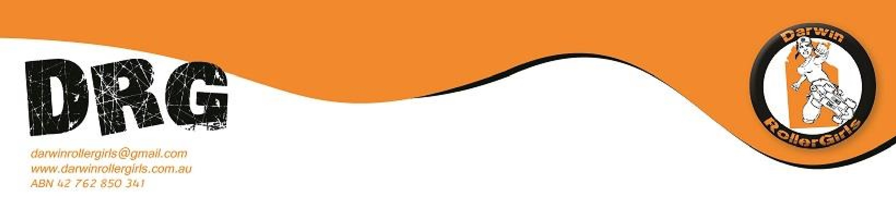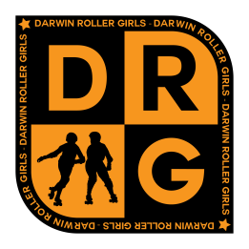Requirements

- No pay, no play. All payment arrangements must be in place before a skater can participate in a session.
- If you choose to not continue the rest of the year in derby you will need to send an email to darwinrollergirls@gmail.com as soon as possible to stop your direct debit payments. Please specify the date of when you will be leaving so payments can cease on the notified date. All payments made before the email is sent will not be refunded.
- In the instance that a member pays all fees upfront, but then decides to leave DRG part way through the block, a partial refund will be issued. All other refund requests will be considered on a case by case basis, and all requests for refund of fees must be submitted in writing to the MC.

